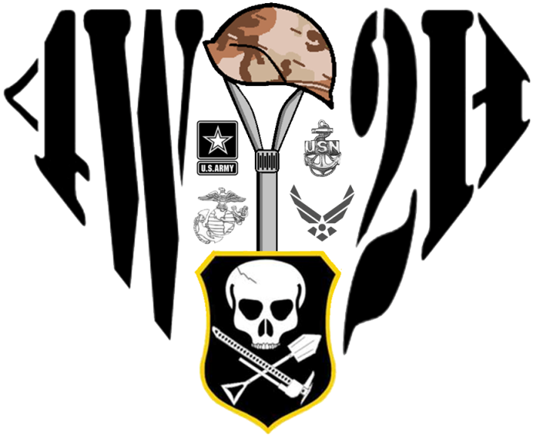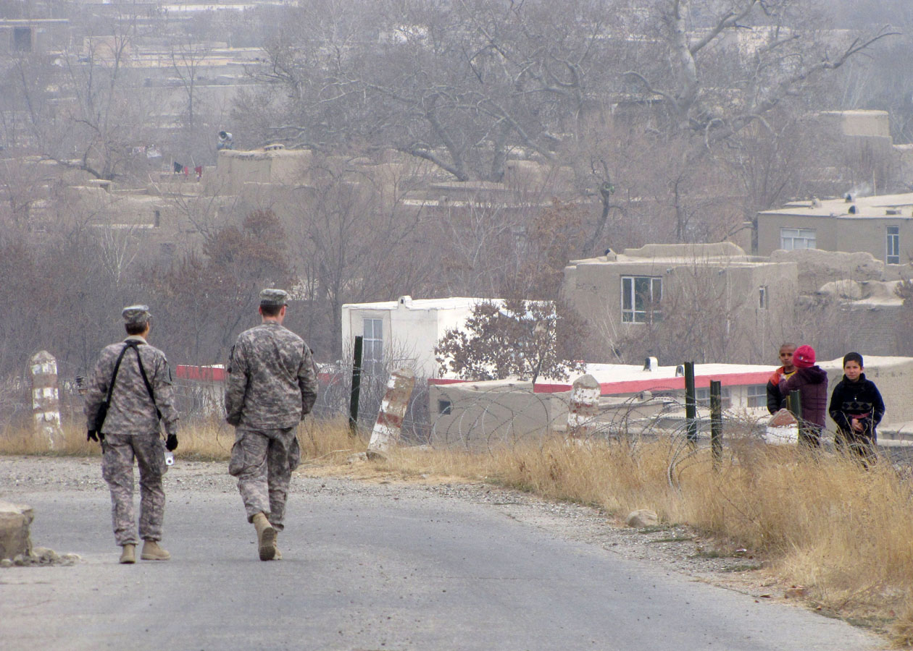

4x4

4Wheel to Heal

Spring 2012 Vol. 1 Issue 1

**4 Wheel to Heal Status Update**

Money Donated: $250

Events:

Big Dog Ice Breakers

Big Dog Spring Fling

Big Dog Main Jambo

Big Dog Fall Crawl

Army 10 Miler

All Breeds Jeep Show

Warrior Visits at WRNMC, Bethesda

Facebook Numbers:

Group Page: 35 Members

Community Page: 121 Likes

Future Plans:

Working with Truckin4Troops

Working out next year's Big Dog Trips

Becoming an official non-profit organization

**The Stage is Set**

*Officially Becoming a Non-Profit*

By the 4W2H Co-Founders,

This past year 4 Wheel to Heal has really come to life. Starting as a 4x4 club idea, we have been able to raise more than $3,000. Some of it was donated, but much of it was used as start up money toward 501(c)3 Non-Profit Organization fees and reinvestment into the organization.

We've been working with Big Dogs Offroad, Poison Spyder Inc., Truckin4Troops and several other organizations to help bring you guy’s better gear. That's all money making to keep us going… but we have also been working with Ward 57, going to the Walter Reed Army Medical Center - now the Walter Reed National Medical Center, Bethesda - and working to bring wounded veterans out on the trails with us. This is no small task. As you know, off-roading can be a bit of an extreme sport that tosses you around. Injuries don't do well with that. But we have met several recovering warriors who want to, and are, joining us next year. This is really what it's all about.

As we move forward, we will continue to work with all these organizations to develop stronger relationships, build trust and friendship, and grow as an organization to do more, and give back to a community that has given so much.

**Thank you - 4 Wheel To Heal**

**Four Wheel to Heal**

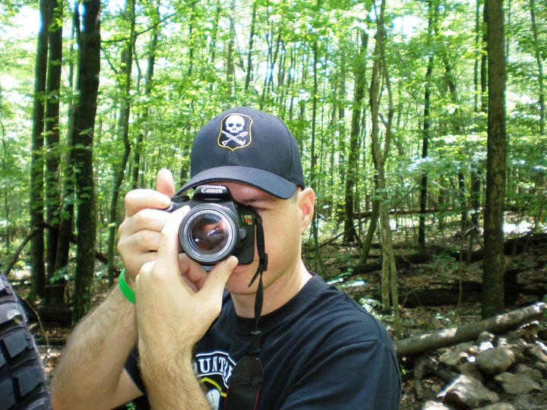

*Why I Do It*

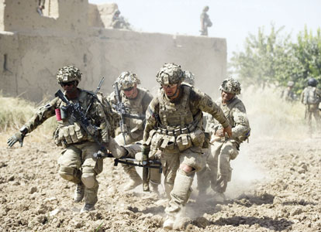

By Mark Schultz

Co-Founder, 4 Wheel to Heal

I have been in the Navy for more than 12 years. In that time I have, like most of today's service members, been to the world's hotspots. I've deployed to Afghanistan, been to Iraq, travelled through Kuwait and conducted anti-terrorism missions in the Gulf.

I am one of the many lucky ones. I came back each time uninjured. I was healthy, both physically and mentally. And shoot, after this last deployment to Afghanistan, I was debt free and had saved enough money, I could buy a Jeep. It's a pass time I've come to enjoy over the past several years with friends.

I was able to get into off-roading because there were service members standing the watch, as the Navy says. Unfortunately, not all of them came home as care-free as I did.

4 Wheel to Heal is an offroad club that supports those service members who have been injured in the service of their country.

Many of those injuries have affected what that Sailor, Airman, Marine or Soldier can do in their off-time. I feel that if I can help provide and interesting, low cost or free activity that gets these troops away from the hospital or stress of healing, I'm able to help repay them for their sacrifice.

I always say, "I wheel with two extra seats, every time." My goal is to fill those seats with those who have served and perhaps sacrificed a bit more than I have. Any money I can help raise for 4W2H is money I know will be going towards non-profit veterans organizations that help our wounded comrades recover a life they once had.

AFP photo

This file photo shows a fatally wounded US soldier being carried into a medivac helicopter by comrades before being airlifted to Kandahar Hospital.



The emblem means a lot to us and this will be 4 Wheel to Heal's official logo. It starts with the entire symbol in the shape of superman's emblem for strength. The center piece is a combat shovel representing all of our fallen American troops with the CBC shield as the tip and dressed with a helmet in dessert camo. Each DOD Branch surrounds the shovel as to show the sacrifice each branch has suffered.

As our supporters grow we want them to know the importance of sacrifice of our cause. We do this because as Americans we owe everything to those men and women who have given everything for our freedom and safety.

www.4W2H.org

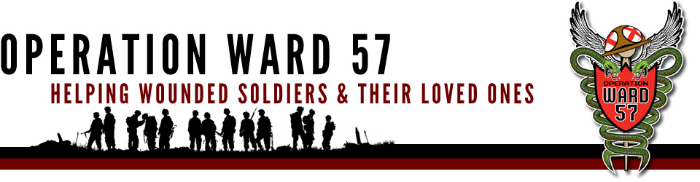

**CBC Proudly Supports Ward 57**

By John Purser

Co-Founder, Country Boy Crawlers

In July, 2011 Nathan Ramos and myself were invited to attend a celebration party for the upcoming closing of Ward 57 at Walter Reed Army Medical Center. We were hosted by Operation Ward 57 a Non-Profit Organization that helps in the wards. This was a great event to attend. We were able to deliver meals to the Wounded Veterans in the Wards as well as introduce Country Boy Crawlers to the Veterans. The amount of knowledge we received from this trip and the exposure to what these Veterans deal with drove us to want to do more for them. Shortly after this event the Co-Founders came together and formed 4 Wheel to Heal and it’s been nothing but success ever since! Thank you Operation Ward 57 for allowing us to attend and help out!

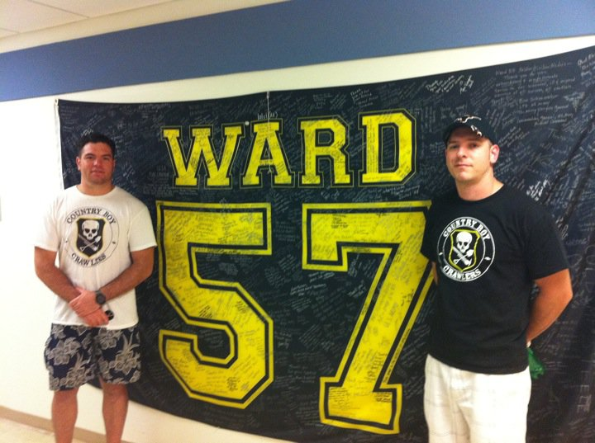

Photo by Brittney Hamilton

Country Boy Crawler Co-Founders Nathan Ramos and John Purser stand in front of Operation Ward 57's football themed banners during a farewell party July, 2011, as the Walter Reed Army Medical Center was getting close to closing its doors and moving to the Bethesda National Medical Center.

*The History Behind the Operation*

Article courtesy of Operation Ward 57

In December 2006, SGT Scott Cameron, an LPN was transferred from Ft. Lewis in Washington State to Ward 57 at Walter Reed Army Medical Center in Washington DC. He and his good friend Deborah Semer made the cross-country journey and immediately visited WRAMC. Within 10 minutes of arriving, Deborah was in tears seeing all of the young amputees, and the full impact of the cost of the war on terror. Deborah picked up a copy of the Stripe military newspaper where she saw a front page picture of Condoleezza Rice and a soldier holding a black and yellow Ward 57 T-shirt.

She immediately bought one to support the ward where her good friend would be working. That first batch of football themed shirts was funded by “The Angels of Mercy” and were created by Lt’s Kevin Jones & Scuba Steve to match the team spirit of the soldiers on the ward and their new “home.” Deborah returned to Seattle to attend to her commitments and would end up traveling back and forth for the next 4 years to support her friend, SGT Cameron, and Ward 57.

After a few months of working on Ward 57, it became clear that additional help and funding was needed to provide wanted and needed items for patient healing and care. In March of 2007, SGT Cameron asked Deborah to get some Seattle Seahawks memorabilia to boost the spirits of a depressed amputee patient from Seattle who was battling to save his remaining foot. Deborah contacted her fellow Seattle Arts Commissioner, Laura “Piece” Kelly, who was the Executive Director of former Seahawk–turned-WA-Redskin running back, Kerry Carter’s “Think Big” Foundation. Both Laura and Kerry immediately jumped in to help.

The Seattle Seahawks put together a gift package that included an NFL football personally autographed by QB Matt Hasselbeck. Deborah flew to DC with the items, where she met with Kerry and his

Continue on page 4

Continued from page 3

former Stanford Quarterback, Chris Lewis to personally deliver the items to the patient. That visit made a tremendous impact on them all and had lasting beneficial effects for the patient’s spirit.

When the outpatient housing scandal hit WRAMC in February 2007 and hospital morale dropped to an all-time low, Deborah, Kerry and Piece created a partnership to start a new program, Operation Ward 57 through Kerry’s Think Big Foundation to recreate the Ward 57 football T-shirts for the patients, boost morale and raise funds for items needed on Ward 57.

The Mauler

**A Custom Fabrication**

Photo By Mark Schultz.

A custom front bumper with stinger and fender flares sits outside Nathan Ramos' apartment in Annapolis, Md., just weeks before the Big Dogs Ice Breakers event this spring.

tell you took a little muscle to get them finished.

Mark and I slowly pieced together the bumper from bolting it to the vehicle and removing it to assure the correct fit. Because it is a wrap- around fender-to-fender front end it was very important that I did this correctly. This process took the longest and although I didn’t plan on the fenders being eight inches wide, the end result came out perfect.

The fourth day was a day for painting and since the welding, molding, and priming had been completed and left to dry all that was needed was a top coat and the truck bed liner application.

After that was said and done, custom plates with the famous “Mauler” were riveted to the final product.

Like many of CBC Co-founders it is important to do all our own custom work. However, I’m afraid the “Mauler” will continue to be a work in progress.

By Nathan Ramos,

Executive Director, 4 Wheel to Heal.

Today in the word of jeeps and other off-road vehicles you notice a sense of originality to the front ends. Whether it is the name running down the sides of the hood, the fender flares, a tube or square faced bumper or a stinger. I wanted all that jazz and decided to incorporate my two front fenders into a stinger style front bumper.

This process took about five days from the design aspect to painting on a bed liner type material. I order six 6-foot lengths of Drawn-Over-Mandrel tubing which is slightly stronger than regular steel tubing. This made the process easier because I could MIG weld everything. Along with the help of Mark Schultz it took me only a few hours to bend the tubing. We used the club’s hand cranked tube bender and both Mark and I can it

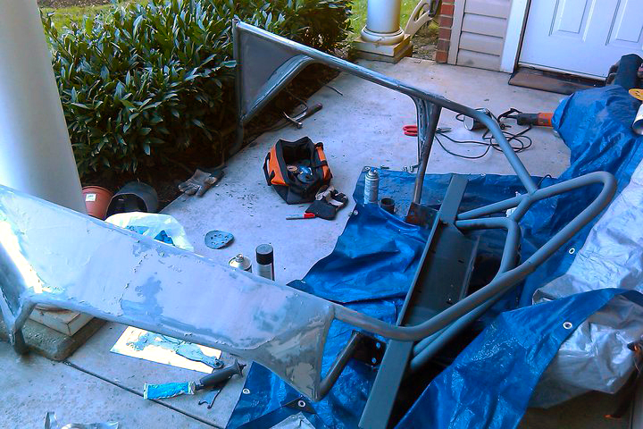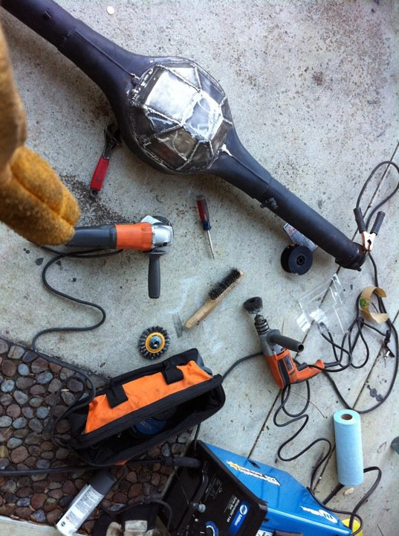

Photo By Nathan Ramos

A Ford 9" axle with a newly welded custom made diff housing. The co-founders of Country Boy Crawlers and 4 Wheel to Heal enjoy building things most people normally just buy. They say, “it saves money.”

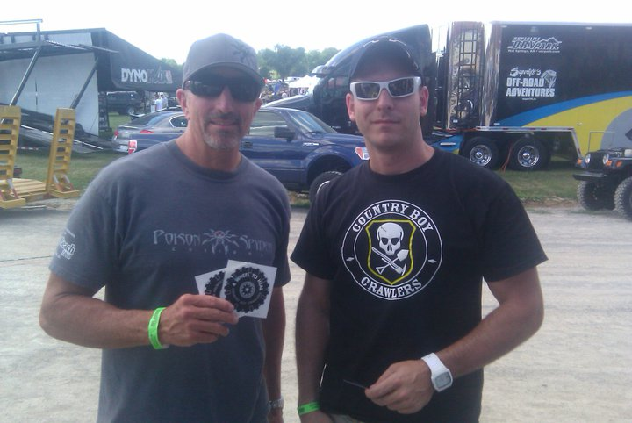

**Making Connections**

**Four Wheel to Heal**

**was founded by**

Nathan Ramos

John Purser

Mark Schultz

John Griffin

**Editor**

Mark Schultz

zennen705@hotmail.com

**Graphic Design**

Mark Schultz

**Photography**

Mark Schultz

Nathan Ramos

John Purser

**Regular Contributors**

Mark Schultz

Nathan Ramos

John Purser

John Griffin

**Editorial Information**

4 Wheel to Heal and Country Boy Crawlers Offroad club welcomes freelance contributors and letters with a focus on enthusiasts, off road vehicles, upgrades and experience as well as service related stories from military and non-military personnel. Text is accepted by email in Word format. Please note, 4 Wheel to Heal is not obligated to publish the information, may edit text and will not be liable for any errors or omissions in the publishing of the material.

Photographic material should be of good to high quality and clearly named. Images will be accepted by email, USB drive or print copies.

4 Wheel to Heal will return original photographic material, but accepts no responsibility for their loss or damage.

**Disclaimer**

The information contained in this newsletter, whether in editorial matter, feature articles or advertisements, is not published on the basis that the publisher accepts or assumes liability or responsibility to any reader of this newsletter for any loss or damage resulting from the correctness or application of such information.



In mid July, 2011, Country Boy Crawlers attended the All Breeds Jeep Show in PA. This was break out event for 4 Wheel to Heal and we were able to raise over $650 dollars at the event. One person who stopped by the booth was Larry McRae, the owner of Poison Spyder.

After an introduction, Larry was nice enough to pose for a picture with John Purser and expressed an interest in helping our cause. Through a few emails Larry McRae and Poison Spyder were gracious enough to donate gift certificates and Poison Spyder swag to 4 Wheel to Heal. These items were raffled off at the Big Dogs Main Jambo event in October raising more than $125! We appreciate the amazing donation Poison Spyder has made towards our cause and cannot thank them enough. We look forward to a growing relationship with this great company!

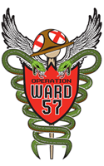

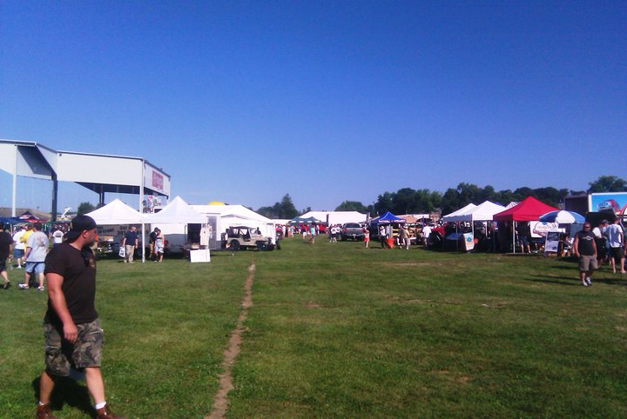

All Breeds Jeep Show

2011

York, PA

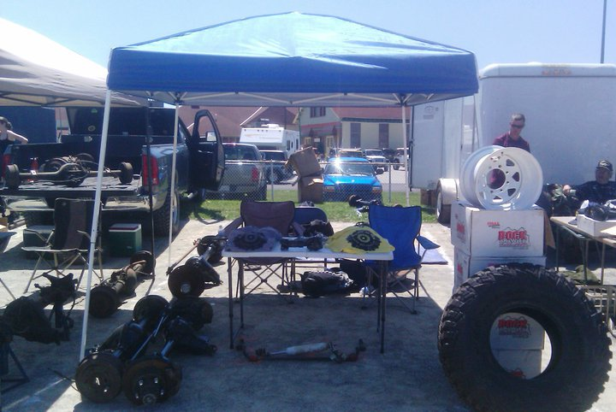

By John Purser

Co-Founder, Country Boy Crawlers

In July, 2011 Country Boy Crawlers attended the All Breeds Jeep Show in York, PA. Rick Bear, President of PA Jeep Club was nice enough to donate a vender spot to 4 Wheel to Heal for the event.

The event lasted 2 days and hundreds of Jeeps and thousands of people were in attendance. In the middle of the arena was an off-road obstacle course built for Jeepers to try their hand at some four wheeling. Vendors from all over the country attended to share their parts and business with Jeep enthusiasts. Food vendors helped keep hunger at bay and provided cold beverages for to help battle the hot summer sun. Attendees were able to view up and coming off-road gear as well as participate in Jeep contests that ranged from stock to buggy builds. Winners were awarded many cool prizes.

Country Boy Crawlers used this event to launch our new 4 Wheel to Heal merchandise and offload some spare Jeep Parts at the swap meet. Overall the event went really well. We made a lot of connections with great Jeep Organizations, like PA Jeep Club, Poison Spyder Inc., and many others. Through the two days of selling 4 Wheel to Heal t-shirts and stickers CBC was able to raise over $650 dollars from the event. With such an outstanding response 4 Wheel to Heal was on its way! We cannot wait to attend next year’s event and invite anyone who owns a jeep to attend!

Photo by John Purser

The Country Boy Crawlers made their presence known at the PA Jeeps 19th Annual All Breeds Jeep Show in York, Pa., July 16 & 17. CBC members were able to sell parts and profits made from merchandise were donated to Operation Ward 57.

Photo By Mark Schultz.

A custom front bumper with stinger and fender flares sits outside Nathan Ramos' apartment in Annapolis, Md., just weeks before the Big Dogs Ice Breakers event this spring.

Photo By Mark Schultz.

A custom front bumper with stinger and fender flares sits outside Nathan Ramos' apartment in Annapolis, Md., just weeks before the Big Dogs Ice Breakers event this spring.

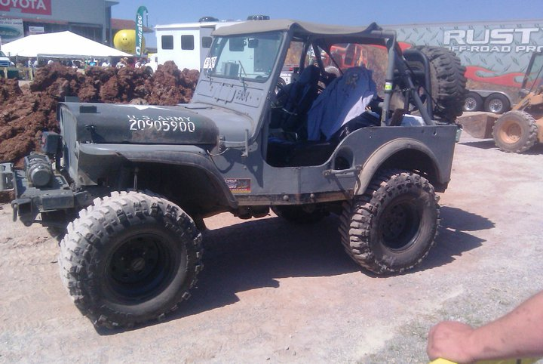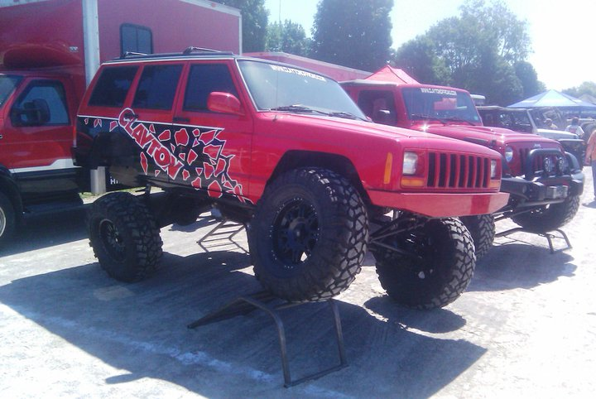

Jeeps of all types and sizes showed up at

the All Breeds Jeep Show in July. New Jeep merchandise was offered by vendors ranging from Poison Spyder to Quadratec. Jeep contests were held for attendees to show off their rigs and an obstacle course allowed Jeep enthusiasts a shot at some 4 Wheeling.

*Bending, Cutting, Grinding, Welding...*

**Creating a Monster**

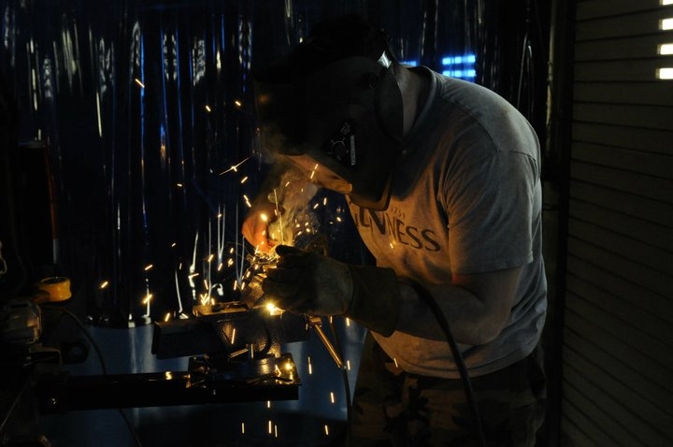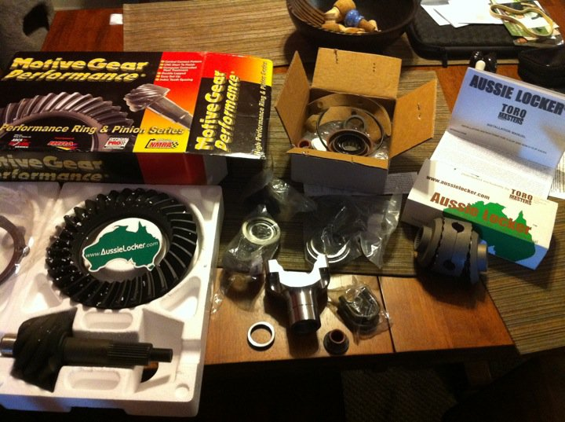

By Nathan Ramos,

Executive Director, 4 Wheel to Heal.

Not everyone begins there four wheel season with “You know what John I think I am going to rebuild a rear end.” However, the guys at Country Boy Crawlers seem to always tackle those options. I initially began with a dilemma that most Jeepers cross when deciding to run larger tires. The Chrysler 8.25 rear differential was a weaker c-clip axle and doing what we do involves a stronger more reliable rear. I looked at many options and it wasn’t until I traded a winch for a 1979 Ford F-150 9-inch that I truly made my decision. The rear was in decent shape, however, it needed an array of parts to complete the monster I wanted underneath the Mauler.

I started by striping the old housing down and welding on a .25 inch differential cover along with the new leaf spring perches at approximately 20 degrees so that the pinion would be angled towards the NP231 transfer case. This is very important when considering the articulation you will get in the rear. The center section needed to be completely rebuilt. I built it with a superlight center section, 31-spline steel spool, 31-spline chromoly axle shafts, 11-inch disk brakes with parking brake, Daytona bearings and pinion support, 4.57 Pro-Ring/Pinion, and a 1350 stainless steel yoke. This process was easier than re-gearing the front Dana 30. This was because the center section is capable of being built away from the axle itself.

After the entire assembly was built it was time to attach it to the Mauler at the shop. This would mean

Photo by U.S. Coast Guard Petty Officer 2nd Class Brandyn Hill

From a tow-hitch mounted vice, Nathan Ramos grinds down a custom made bracket for the new suspension he's putting on his YJ.

I needed to drive the Cherokee to the shop, disassemble the Chrysler 8.25 and then attach the Ford 9. This process took about a day. The picture above shows me adjusting the shock mounts on the axle. After the axle was under, minor adjustments needed to be made so everything would fit. This included a new driveshaft, new leaf springs, bump stops, and brake lines.

The final test is a highway test and an off-road test. I put the Mauler on 37 inch Pit bull Rockers and can travel up to 70 mph without significant vibrations. The key factor is the significant amount of traction and strength off-road. This axle has been put to the test and has passed.

The Mauler still needs attention and future builds will only make it better. I wanted my vehicle to be fully capable to carry a few honored veterans safely through the trails and give them the thrill ride I get every time I Four Wheel.

Nathan Ramos prepares to re-gear his new Ford 9-inch axle before installing it on his Jeep.

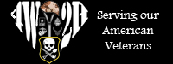

**If you are interested in volunteering, email us at** [**info@4w2h.org**](mailto:info@4w2h.org)**.**

**Visit our website at** [**www.4w2h.org**](http://www.4w2h.org) **to learn more about our cause.**