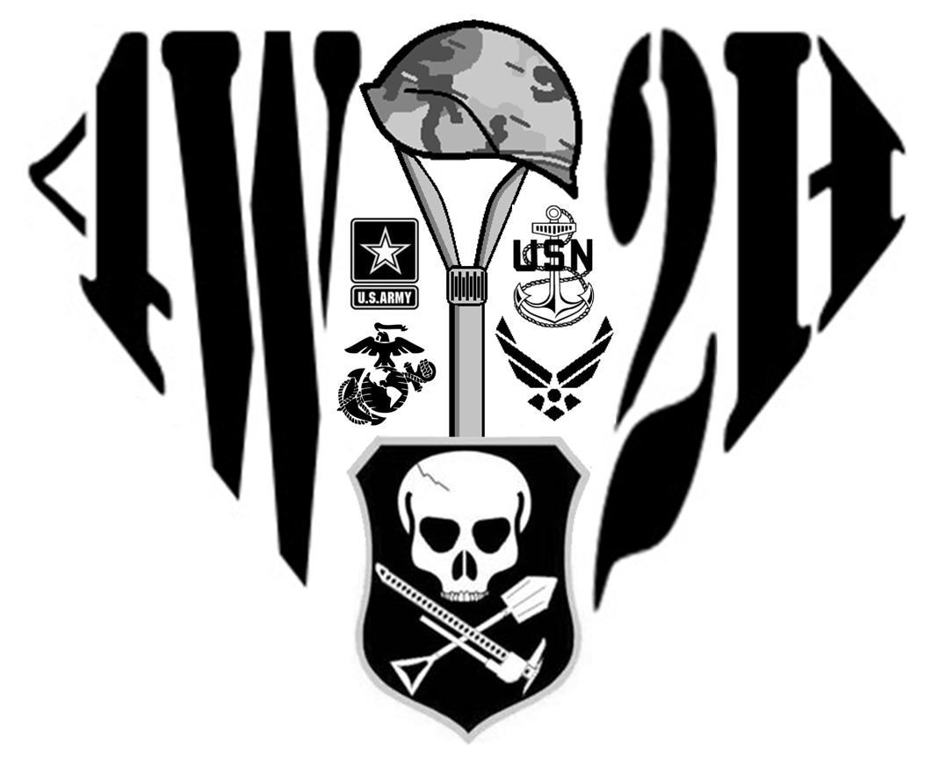 | 4 Wheel to Heal | 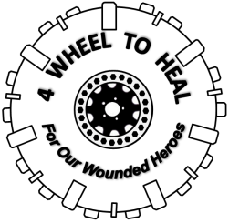
Club / Association / Organization Application
Personal Information:
Club Name: |  |  | Date of Application:
Point of Contact Address: Street

City: | State: |  |  | Zip code:
POC Email Address: |  | POC Phone Number:
Club Information:
Number of Members

Website (Facebook, etc):

Questionnaire:
What types of vehicles are involved?

What safety gear does your organization require?

What Wheeling locations does your organization visit?

Tell us a little bit about your organization and what other charity events you may have been involved with:

Rules and Guidelines to Follow:
All drivers must have the appropriate safety gear in their rig to transport wounded vets sponsored by 4 Wheel to Heal. Our requirements are:
Seat Belts or Harnesses
Fire extinguisher
Grab handles that may have to support Veterans with disabilities
Helmets for serious wheelers

Keep in mind of the severity of your wheeling; no one wants to roll their rig and it is imperative that the minimum safety equipment is available to prevent any unnecessary injuries.

Drivers will not consume alcohol prior to or during a trail ride with a veteran.

Always be safe and cautious while transporting Wounded Veterans. Keep in mind that these guys/girls may have physical or mental handicaps and always be courteous of their needs. Some Veterans have psychological disabilities so please watch the tone of your conversation and first gauge what appropriate subjects your club may discuss when around a Wounded Veteran. 4 Wheel to Heal will do it’s best to pass along any special needs, restrictions or requirements prior to trail rides.

Advisory:

A check of the volunteer applicant’s criminal history could be made to verify the responses to the above questions for the sole purpose of ensuring the safety of its staff, volunteers and visitors. No applicant will be denied volunteer status solely on the grounds of conviction of a crime.

The nature of the offense, the date of the offense, the surrounding circumstances and the relevance of the offense to the position will be considered.

Liability and Emergency Contact Information:

A liability release form will be required for both driver and Wounded Veteran. This is a standard requirement for all events that involve off-roading. Additionally, for your clubs safety, all veterans mush fill out an emergency contact sheet. Please contact 4 Wheel to Heal for all additional information.

Members List:

If more space is needed please include another sheet. Only listed members will be covered without a separate volunteer application.

Note: If someone has been convicted of a felony please have that member fill out their own volunteer application.

Name Phone # Address Signature

__________________________________________________________________________

__________________________________________________________________________

__________________________________________________________________________

__________________________________________________________________________

__________________________________________________________________________

__________________________________________________________________________

__________________________________________________________________________

__________________________________________________________________________

__________________________________________________________________________

__________________________________________________________________________

__________________________________________________________________________

__________________________________________________________________________

__________________________________________________________________________

__________________________________________________________________________

__________________________________________________________________________

__________________________________________________________________________

__________________________________________________________________________

Sign and Submit:

Sign Full Name:

“I certify that all information submitted by me on this application is true and complete. I understand that if any false information, omissions, or misrepresentations are discovered, my application may be rejected and active volunteer status may be terminated at any time. In consideration of this club application, I agree to adhere to the policies and regulations of 4 Wheel To Heal, Inc., and I agree that my volunteer status can be terminated, with or without cause, and with or without notice, at any time by 4 Wheel To Heal, Inc.”

