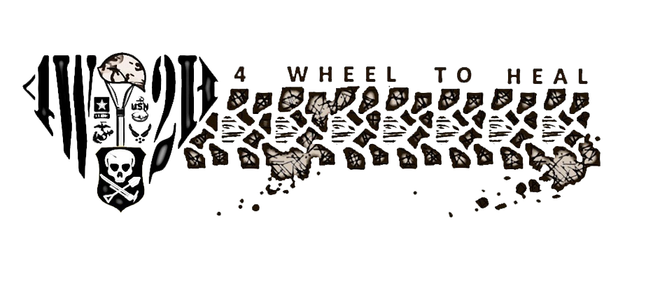

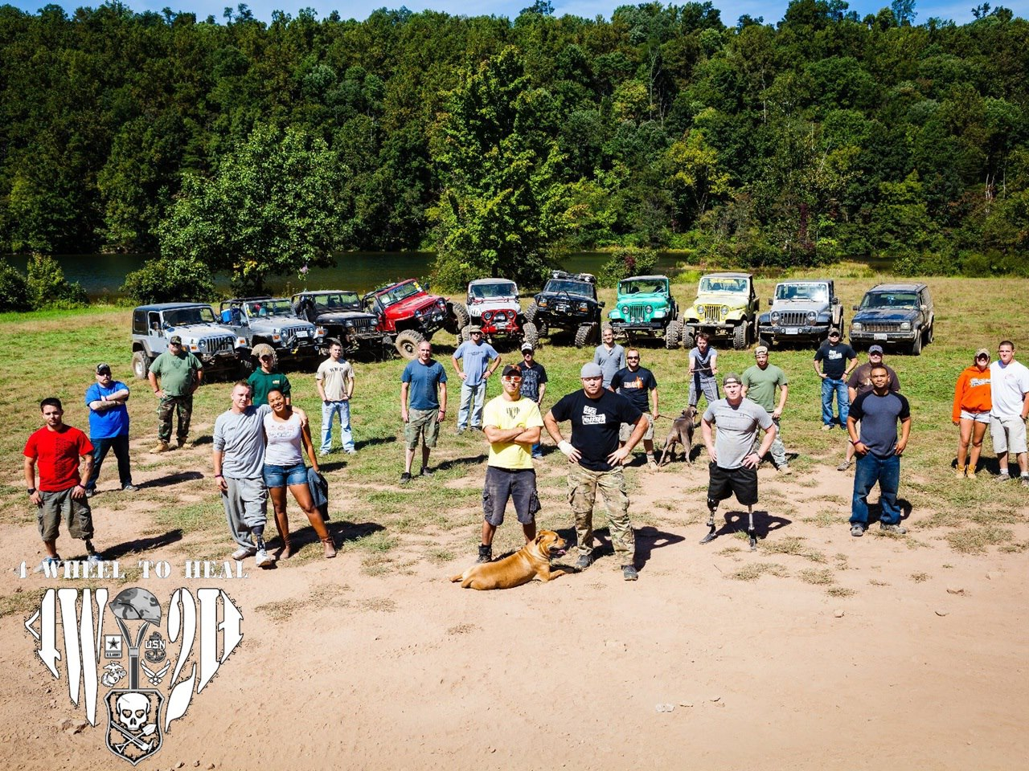

Winter 2012 Vol. 1 Issue 2

Big Dog’s

Main jambo

Story by Val Gempis

Photos by Keith Gillan  
Air Force News Service  
9/28/2012 - **GORE, Va. (AFNS)** -- Airmen from the Washington area have found a unique way to help wounded warriors, one that takes them out of the daily grind, far removed from their normal surroundings.  
 Tucked away in the backwoods of northwest Virginia, about 90 miles from Washington, a non-profit organization called "4 wheel to heal" provides wounded warriors with an outdoor experience ranging from crawling through the mud to riding four-wheelers across rugged terrain, camping and firing weapons on the range.  
 "The goal of our organization is to help boost morale for these wounded veterans and give them an experience they'll never forget," said Tech. Sgt. Nathan Ramos, a co-founder of the organization. He is also an Air National Guard airman with the 113th Air Wing at Joint Base Andrews, Md.

Continued page 2

Continued from page 1

Ramos said that he and three other service members created the organization, originally for those who enjoy four-wheeling, but quickly changed after a visit to see wounded warriors at the Walter Reed National Military Medical Center, Md.  
 "I deployed to Iraq in 2003, and although I came back unharmed, I understand what these wounded warriors are going through," said Ramos. The group founded the "4-wheel to heal" program in July of 2011, and has taken wounded warriors on several trips to the Gore, Va., site.  
 Army Sgt. James Nicholson is one of those warriors assigned to the Wounded Warrior Battalion at Bethesda. He lost a leg during a deployment to Iraq in 2009. "This is a great relief from the everyday grind," said Nicholson. He said that he didn't know what to expect during his first visit, but knew he didn't want to sit around the house and do nothing.  
 Nicholson said that he discovered the organization provided more than just a place to "hang out," it also provided a sense of family. "The best part of this place is the camaraderie. You're with people who know what you're going through, and they know how to talk to you and be around you. You don't have to explain anything to them."  
 Nicholson's wife, Dennise, say she needs no explanation about why or how "4 wheel to heal" has helped her husband. She said that after accompanying him on his first trip, she could immediately see the benefit in his attitude. "He was so excited to do it again, and all he talked about was preparing and buying equipment for the next trip."   
 And while Denisse doesn't understand the excitement about crawling and driving over rocky terrain, she likes seeing her husband let loose. "It's a nice getaway for him and he's truly happy and relaxed here."  
 For many of the competitors, relaxing didn't quite fit their experiences. Mud bugging was a competition where vehicles or rigs are driven through a pit of mud. Called "big dogs off-road," it began just after nightfall with the sounds of more than 300 people screaming and the roar of rigs and buggies engines revving. Throughout the night, vehicles jammed in the mud, often slamming into the pits at full speed.  
 Staff Sgt. John Purser, also assigned to the 113th AW, is the president of the organization and believes that driving the rigs through the rough terrain and rocks is not the only reason these wounded warriors enjoy their visits here. "It's really special when you sit around the campfire at night and listen to these warriors open up about their experiences that they normally wouldn't talk to people about. Their stories are inspirational and it raises all of our spirits."

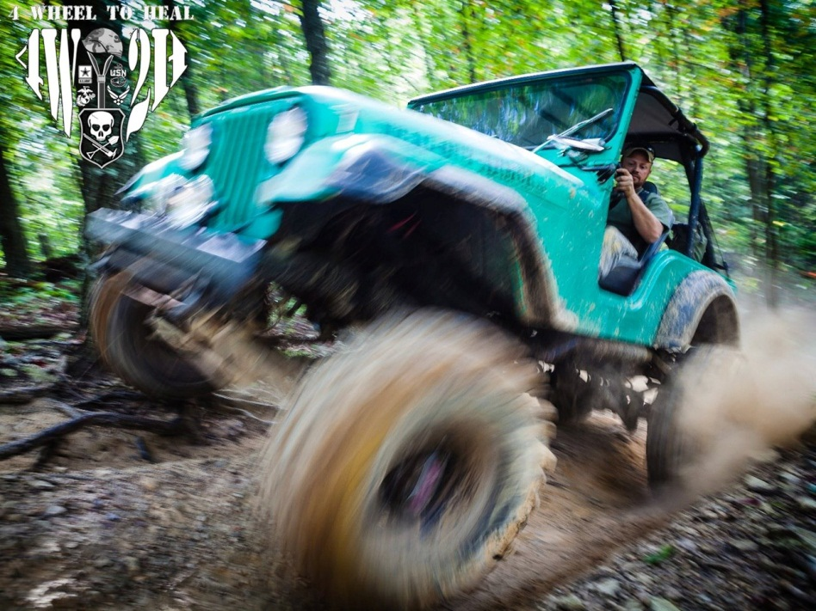

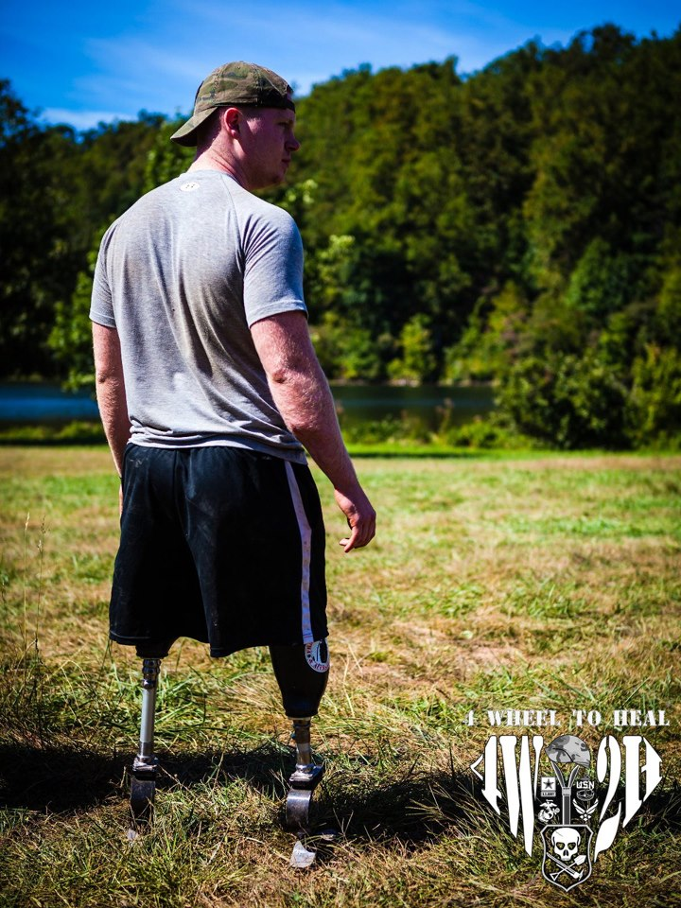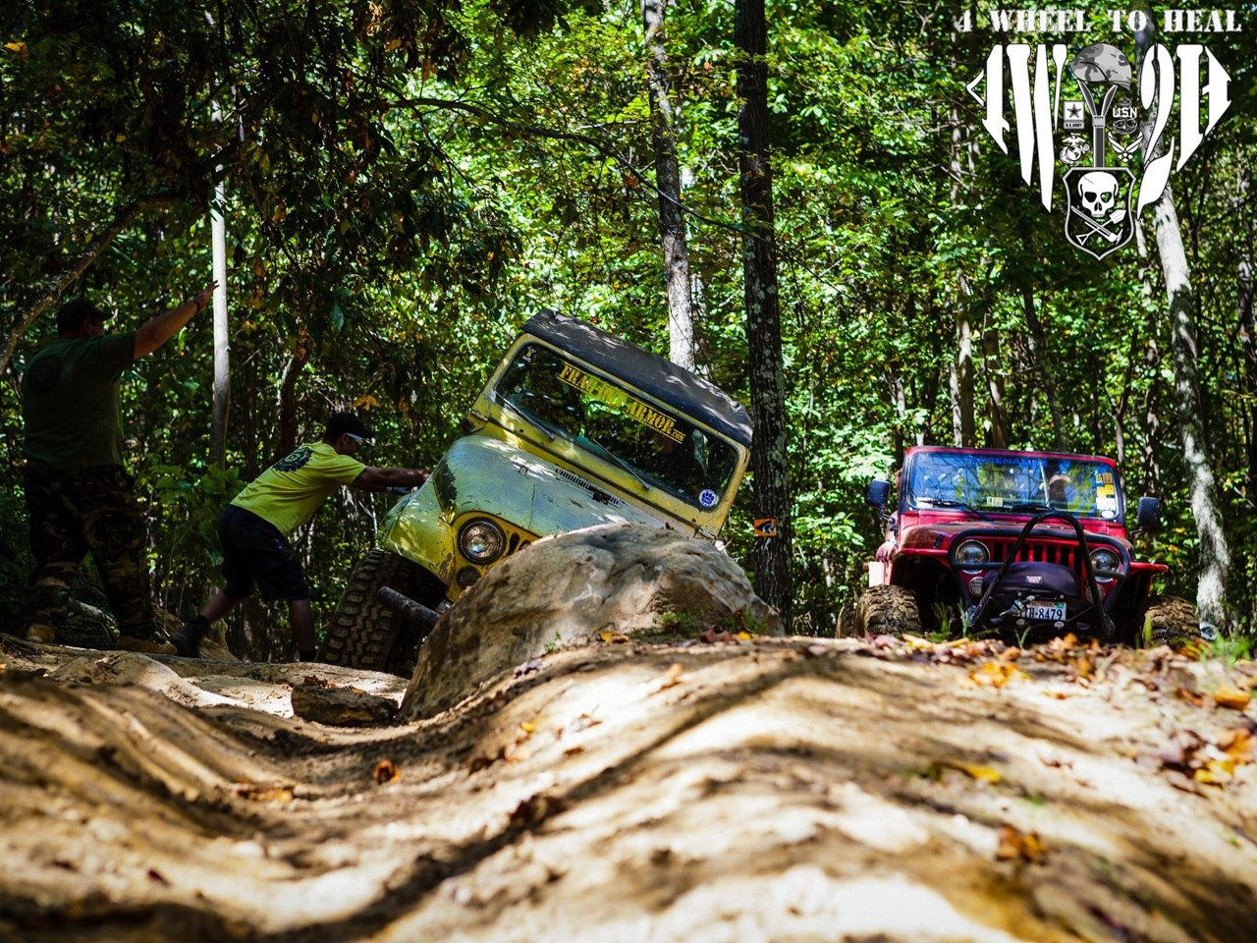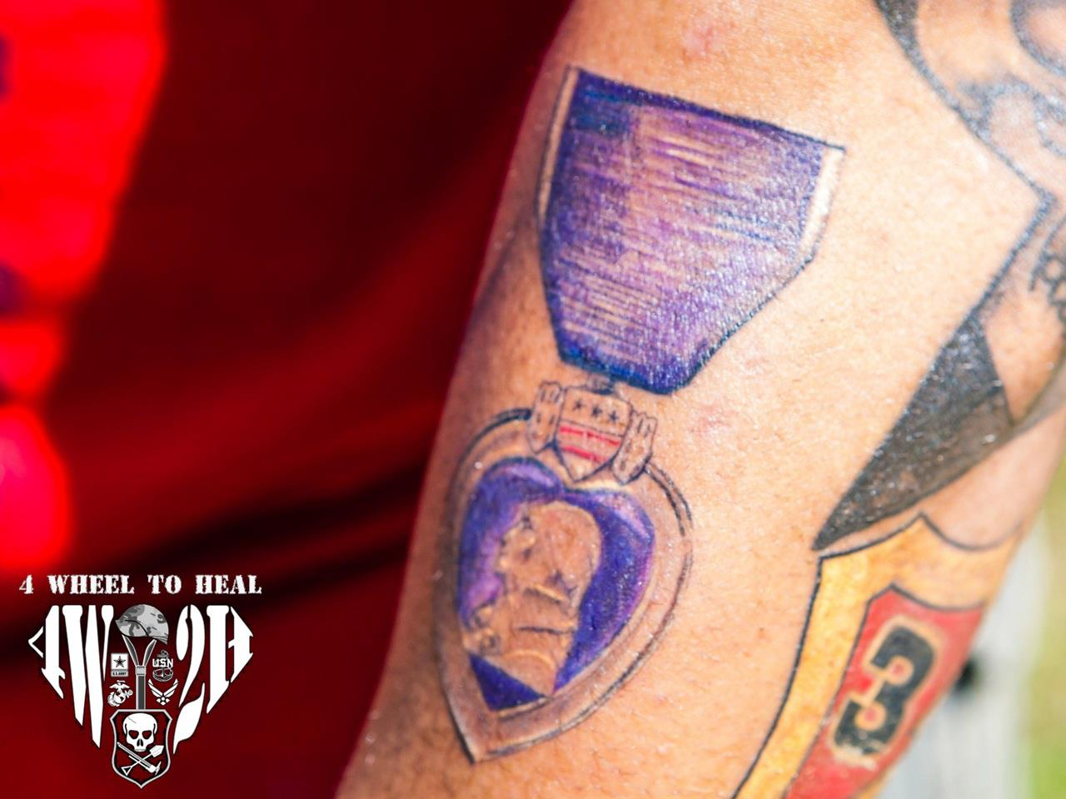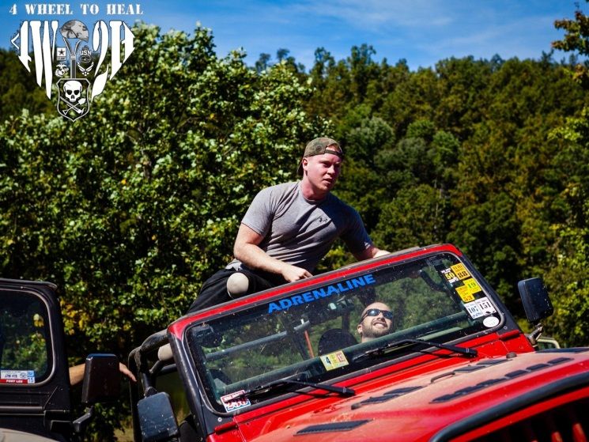

Above: John Purser holds a Jeep up as it maneuvers through an obstacle… or at least he feels he is.

Right Top: John Curtain looks over the lake at the Cove campground during Big Dogs Main Jambo.

Right Center: John Patterson shows off his Purple Heart tattoo.

Right Bottom: John Curtain enjoys a ride while taking a break from some of the harder trails.

**6 Vets, 6 Times the Fun**

Big Dog’s

Summer Slam

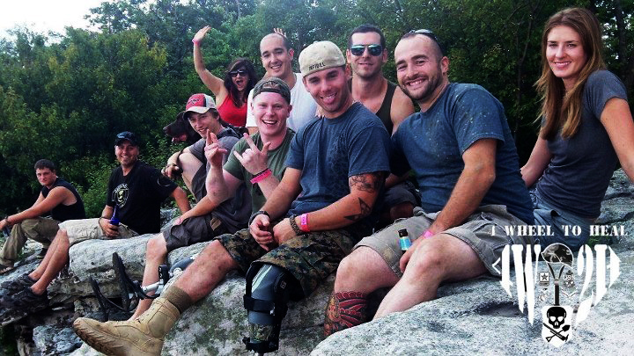

Big Dogs Summer slam started off on a rainy Friday morning for 4 Wheel to Heal and the three wounded veterans they brought out for the weekend, John Patterson, Jimmy, and John Curtain. It wasn’t long after getting set up though that the weather cleared and gave way to a beautiful weekend!

After everyone was settled in and had camp set up, Nathan Ramos and John Purser with 4W2H took the guys out for a night run. There’s nothing like trudging through the trails with just your headlights leading the way!  
 As usual, the crew was up and rolling down to the drivers meeting at 0900 and figuring out the plan for the day. They met up with the guys from Frag Out Armor and hit the trails.

If you know anything about Big Dogs, you’ll know that starting the day out by heading up U-Turn Hard is a great way to get the adrenaline pumping!

“The guys absolutely loved wheeling,” said John Purser, President of 4 Wheel to Heal.

“I ended up having a leaky fuel line at the top of U-Turn hard so we stopped to fix it,” said J.P. “After the fix we broke off to welcome ‘Truckin4Troops’ who stopped in for a trail ride down Trickle before heading home.”

Rounding out the day, the crew headed up to Pinnacle and hiked out to the peak. It’s amazing what these warriors are capable of with their prosthetics!

“On the way down we hit the bunny hole in Dave Pendergraph’s rig and then finished the night out at the beach for a tiki torch get together,” said J.P.  
 Rounding out the weekend, Nate took John, Jimmy and Jon up to the gun range to have some fun shooting a variety of rifles, shot guns, and pistols.

Above: Wounded Veterans John Curtain and John Patterson, 4W2H President John Purser and Secretary Dave Pendergraph hang out with the Country Boy Crawler crew during the Big Dogs Summer Slam event.

Below: The CBC Crew having fun on the rocks at Summer Slam.

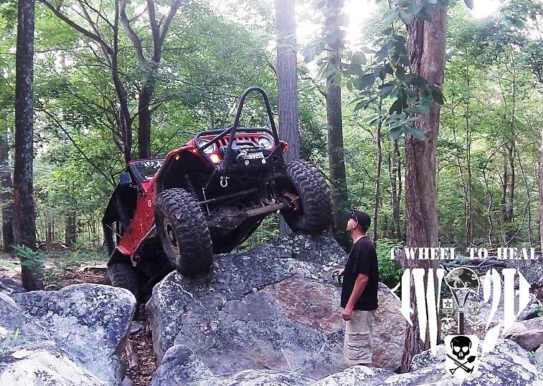

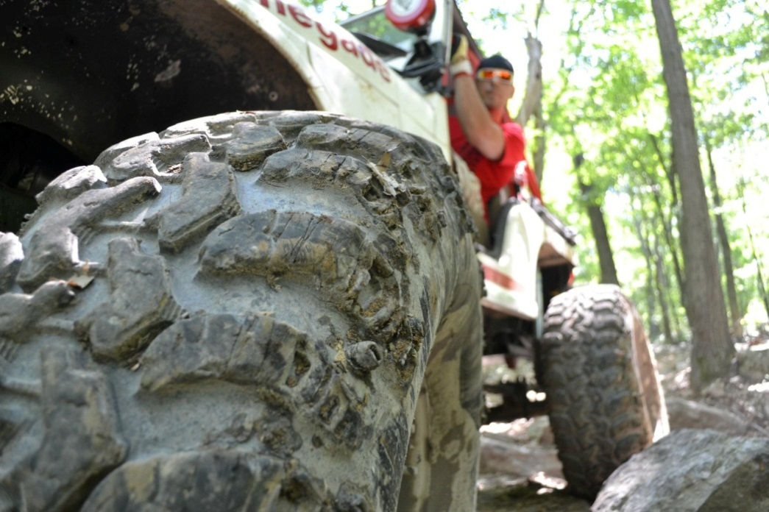

Big Dog’s

Spring Fling

John Purser, Co-founder and President of 4 Wheel to Heal, leans out of his modified jeep to check his route (and make sure he doesn’t run over the photographer) during one of the many runs the crew made during Big Dog Offroad’s Spring Fling event in June. 4W2H takes warriors on five of these weekend-long events each year and is always looking for new opportunities to find warriors and event locations. If you know a wounded veteran who would be interested in joining us, please email us at info@4w2h.org.

An update from J.P. on the Big Dogs Spring Fling:

“We headed up Thursday afternoon (June 7, 2012) to the Cove Camp Ground. We had planned on 3 Warriors with us. John, Bobby, and John Patterson were the Warriors set to come with us. John and Bobby weren’t able to make it at the last minute. Bummer! We lightly wheeled on Friday and then John Patterson arrived Friday night just before the mud bogs.

We went to the mud bogs and this is where stuff went crazy for 4W2H!

A Retired Lt Col named Greg Bennett stepped up and offered a $500 donation in the name of the individual who won best in show for the night to go to 4W2H! Shortly after that a company made up of a few EOD guys named Frag Out Armor stepped up and matched the donation! Greg then stepped up from $500 to $600! Not too many people attempted the mud holes but the guys from Frag Out Armor offered to let John Patterson make a run at it in their Open Cherokee. Nathan, and John Patterson climbed into the vehicle and made one of the best runs we have seen at the mud hole! John Patterson ended up getting best in show and donated the winnings of the mud hole to 4W2H. So before we had even started day 2 we already had a $1,500 donation! Thank you Lt Col Bennett and all you guys at Frag Out Armor!

We decided to go out wheeling and made a night run of Quarum. I took John Patterson in my rig, the Tank Killer, and we had a solid ride down the trail. We had to stop to fix a flat on Matts Toyota half way down but it just made for a good Big Dogs Wheeling Story!

On Saturday we set up the table at the morning drivers meeting and got the word out about 4 Wheel to Heal before we went wheeling. Nathans Cherokee was broke, so he ended up stayed behind and worked on that for the rest of the day. We went and rode Camp 8 in the morning with John Patterson riding shotgun.

Then we proceeded to head up to Pinnacle. At the bottom of Pinnacle, J.P.’s rig overheated and needed some TLC to get her

Continued Page 5

Continued from page 4

motivated to take the long trip to the top. At the top we were able show John Patterson the view and take some pictures. Coming back down from Pinnacle I ran out of gas. After an hour the guys were able to bring me some and then we diagnosed I had an ignition issue. We called it a day and I went and set up the merchandise tent and the put the Tank Killer on the Race Ramps. That night at the bonfire we raised another $100 donation! John Patterson also got to climb the Rock Pile in MadMatz new Rock Buggy which was pretty awesome!

All in all it was a great weekend! We raised a total of around $2400. That’s a record for the books and will definitely help get more wounded veterans out on the trails with us!”

We also want to thank our volunteers Michael Meade and Eric Nault; both are active duty security forces out of Andrews Air Force Base. They were a great help!”

**4 Wheel to Heal Status Update**

Money Donated: $1,684

Events:

Big Dog Ice Breakers

Big Dog Spring Fling

Boulder Bash

Big Dog Summer Slam

PA All Breeds Jeep Show

Big Dogs Main Jambo

Big Dogs Summer Slam

Boulder Bash

Facebook Numbers:

Community Page: 3,691 Likes

Future Plans:

Grow our Volunteer Base

Bring more Warriors on Trips

Develop Countrywide 4x4 Club Involvement

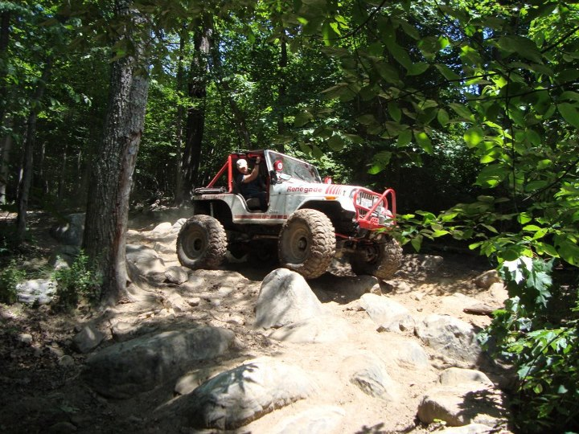

***Second Big Dog’s Event of the Year***

*For Those Who Didn’t Make It Back*

In our line of work, we meet all sorts of people with many stories to tell. Sometimes, those stories are unexpected and put things into perspective. Nathan Ramos was out at the PA All Breeds Jeep show manning the 4 Wheel to Heal booth and a woman came up to him and wasn’t really able to express her thoughts. She walked away and came back a little later.

This is Nathan’s account:

“She sounded like she wanted to express something but couldn’t get out the right words. After more conversation, I realized she was telling me her son was killed in action overseas. She started tearing up and then I started tearing up. Hard as it was for her to talk or think about, she still wanted to support 4 Wheel to Heal by buying bracelets for her kids. I handed her the four bracelets to take to her kids, gave her a hug and thanked her for her son’s service. It’s moments like that that make the entire trip worth it.”

4 Wheel to Heal’s Take:

Stories like this really make us think about what we are doing, and why we are doing it. 4 Wheel to Heal is a veteran run organization. All of its co-founders have been deployed to Iraq and or Afghanistan. We’ve been to military funerals and appreciate the sacrifice those heroes have made serving our country, and keeping us free.

Sometimes we get caught up with the business of things, and it’s good to be reminded of what brought us together in the first place.

Thanks to all who have served, who have made the ultimate sacrifice, and thanks to those who have survived with battle scars. It’s these thoughts that bring us back to our mission; to boost the morale of those who are still fighting physical or mental battles here at home.

- 4 Wheel to Heal

John Owen Patterson, a wounded veteran from Operation Iraqi Freedom, rides down Camp 8 with 4 Wheel to Heal Co-founder and President John Purser in the “Tank Killer” June 8, 2012, during the Big Dogs Offroad’s Spring Fling event in Cove, Va.

**You Are Not Forgotten**

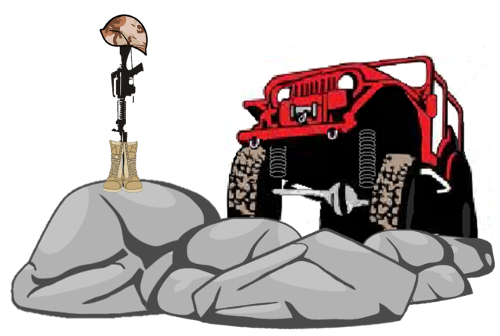

4 Wheel to Heal is a non-profit organization that needs your support! We are committed to using 100% of your donations to taking wounded veterans on the trails.

Your commitment helps pay for food, camping supplies and registration fees for these warriors.

**Visit www.4w2h.org/donations and give today!**

**We need Your Help!**

**Four Wheel to Heal, Inc.**

**was founded by**

Nathan Ramos

John Purser

Mark Schultz

John Griffin

**Editor**

Mark Schultz

Mark.schultz@4w2h.org

**Graphic Design**

Mark Schultz

**Photography**

Nathan Ramos

John Purser

Keith Gillan

**Regular Contributors**

Mark Schultz

Nathan Ramos

John Purser

John Griffin

**Editorial Information**

4 Wheel to Heal welcomes freelance contributors and letters with a focus on enthusiasts, off road vehicles, upgrades and experience as well as service related stories from military and non-military personnel. Text is accepted by email in Word format. Please note, 4 Wheel to Heal is not obligated to publish the information, may edit text and will not be liable for any errors or omissions in the publishing of the material.

Photographic material should be of good to high quality and clearly named. Images will be accepted by email, USB drive or print copies.

4 Wheel to Heal will return original photographic material, but accepts no responsibility for their loss or damage.

**Disclaimer**

The information contained in this newsletter, whether in editorial matter, feature articles or advertisements, is not published on the basis that the publisher accepts or assumes liability or responsibility to any reader of this newsletter for any loss or damage resulting from the correctness or application of such information.

**Welcome Dave!**

David Pendergraph was elected in December into the position of Secretary for 4 Wheel to Heal. We’d like to say THANK YOU for his continued and growing support and WELCOME to our organization!

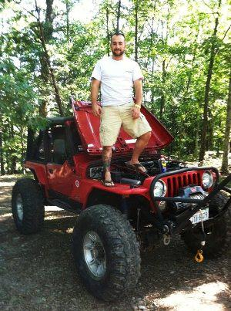

A Little About Dave:

David (Dave) Pendergraph is a Lead Engineering Technician working for an engineering firm in the Northern Virginia Area. Since 2004 Dave has been supporting DOD/Military, Department of State and other government contracts both in the US and all over the world. Much of his overseas time (nearly 5 years) has been spent alongside the military in multiple locations. Dave is an avid outdoorsman and loves to be out on the trails. He currently owns his second jeep, a 2000 TJ built for rock crawling. After meeting Nate Ramos and John Purser (Co-Founders) a couple years ago at a four wheeling event David decided to get involved and start helping out with 4W2H.