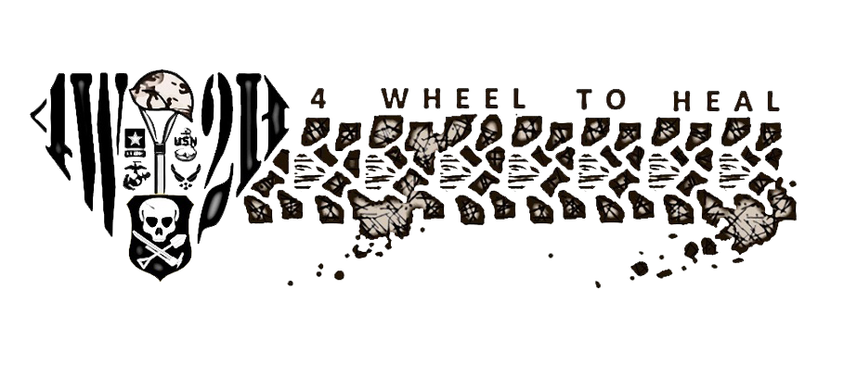

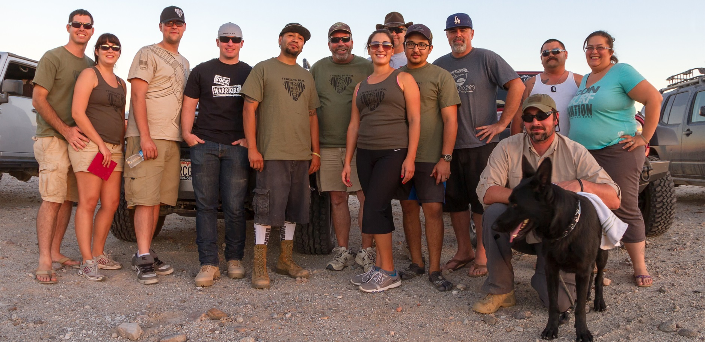

Spring 2014 Vol. 2 Issue 1

**OPERATION DESERT FUN**

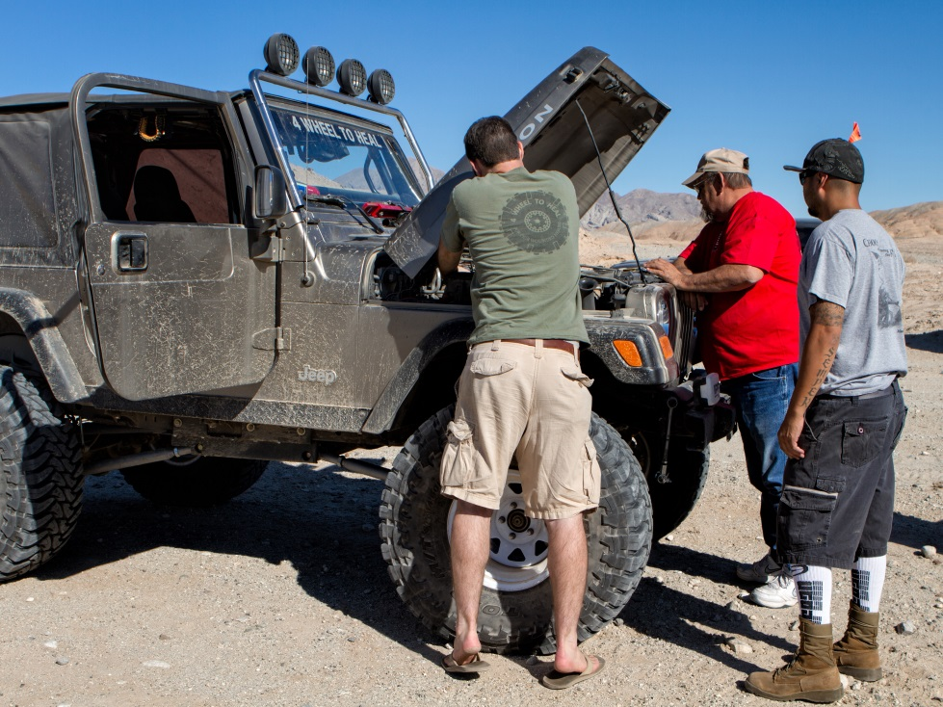

Story and photos by Lori Carey  
 4 Wheel to Heal brought 5 Warriors out for a weekend of wheeling and camping in the California desert as part of Operation Desert Fun 11. Operation Desert Fun (ODF) is hosted by the California Association of 4WD Clubs every October to benefit the Paralyzed Veterans of America Cal-Diego Chapter and it’s a great way to kick off the desert off-roading season.

ODF kicked off under a full moon at the Truckhaven 4x4 Training Facility in Ocotillo Wells. After setting up camp we spent the evening socializing and getting to know each other. We had a booth set up in the main camp to pass out information and sell merchandise. ODF is open to all 4x4’s, motorcycles, ATV’s and side-by-sides so there was a variety of trail runs from which to choose. Our big

**Continued on page 2**

**Continued from page 1**

decision that night was agreeing on which trail run we were going to join in the morning. We had a variety of capabilities in our group, from stock to highly modified, so we decided to do a moderate trail through the scenic Borrego Badlands.

The next morning Jennifer Schultz stayed behind to man the booth while the rest of the crew joined the 35-vehicle lineup. After a brief drivers’ meeting we hit the trail into the Badlands.

After winding our way through the Badlands via Arroyo Salado Wash we stopped to see the Pumpkin Patch. Next we went to the Devil’s Slide area to play on the steep sand hill and have lunch while watching the bike and ATVs tackle the 200-foot high decomposing mountaintop for which the area is named. After lunch we traveled on the high speed Shell Reef Expressway to the Mud Hills, where the group split up with stock SUVs heading back to camp and those who wanted a bigger challenge sticking around for some play time.

Eventually, we all made it back to camp and had a relaxing dinner before the raffle started. The benefit raffle lasted for hours. None of us won any big ticket items but it was still an enjoyable evening.

Thank you to Cal-Diego PVA for inviting us to Operation Desert Fun and a big thank you to all of the volunteers who came out to help. We had a great time and can’t wait to do it again next year!

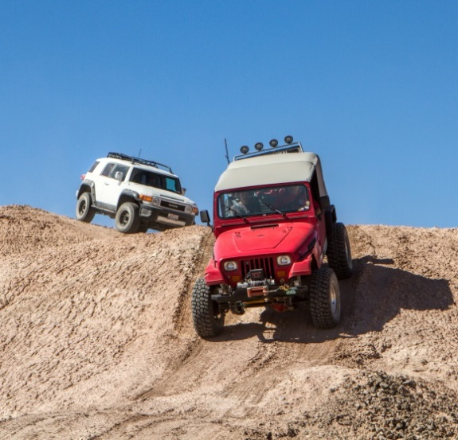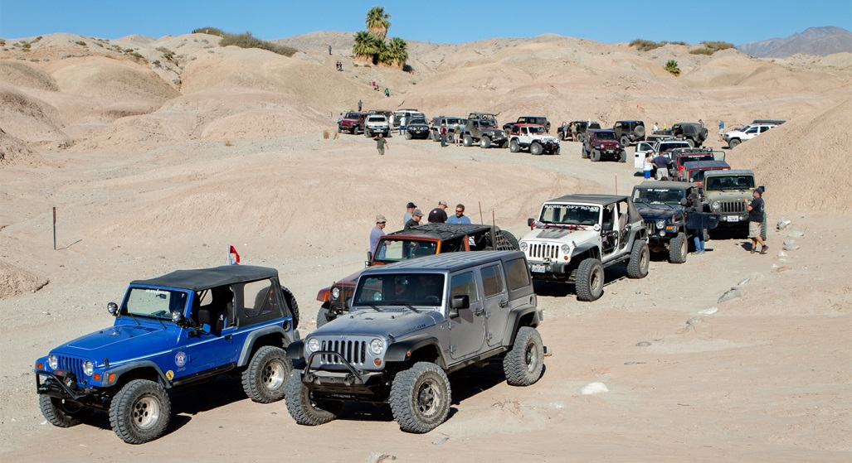

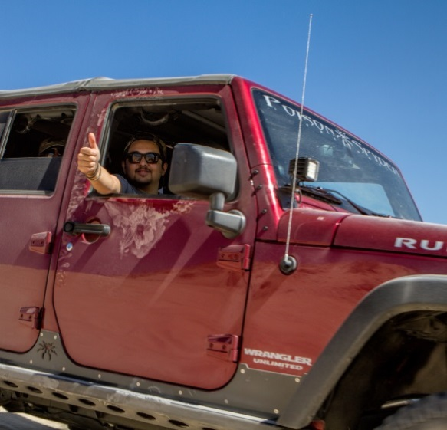

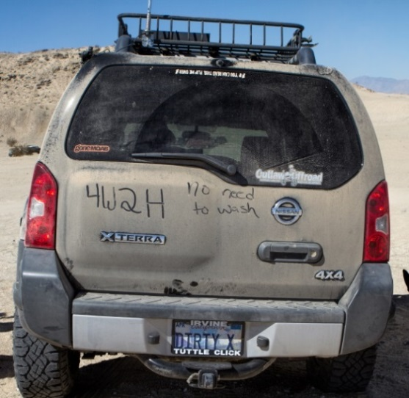

**Celebrating the Holidays with Operation Ward 57 at WRNMMC**

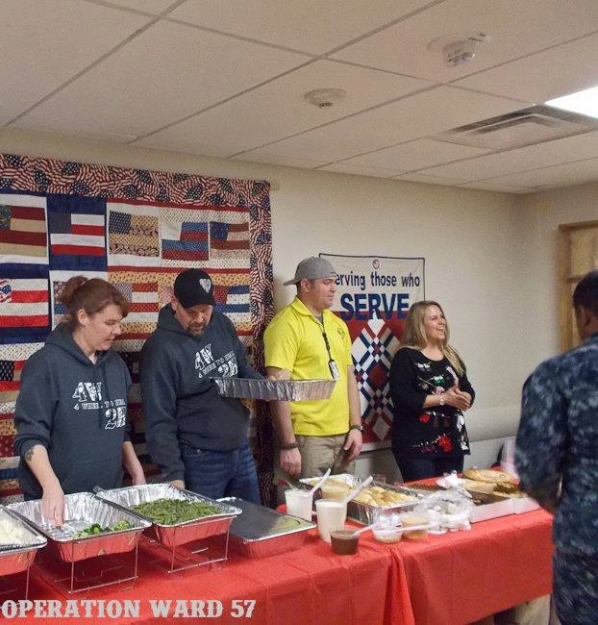

4 Wheel to Heal joined Operation Ward 57, another non-profit organization, to help with their annual Holiday Dinner that they host at Walter Reed National Military Medical Center. This was our third year working together, serving more than 100 meals to staff and wounded warriors on the 4th floor.

4 Wheel to Heal President John Purser, Executive Director Nathan Ramos and volunteers Trina and Mark Kersh, spent the day on the unit spreading holiday cheer with a hot meal and friendly smile, showing support to the warriors who are unable to go home for the holidays.

After the dinner was finished they moved down to the Warrior Café in Building 62 and had the opportunity to spend some time with warriors and their families. Operation Ward 57 had a musician playing music and handed out gifts to the children of the warriors. This event is something 4 Wheel to Heal loves being a part of and looks forward to each year.

In mid-December, Nathan Ramos, Trina and Mark Kersh, and John Purser help volunteers with Operation Ward 57 serve a holiday meal at the Walter Reed National Military Medical Center in Bethesda, Md.

Photo courtesy of Operation Ward 57

Big Dog’s

Spring Fling

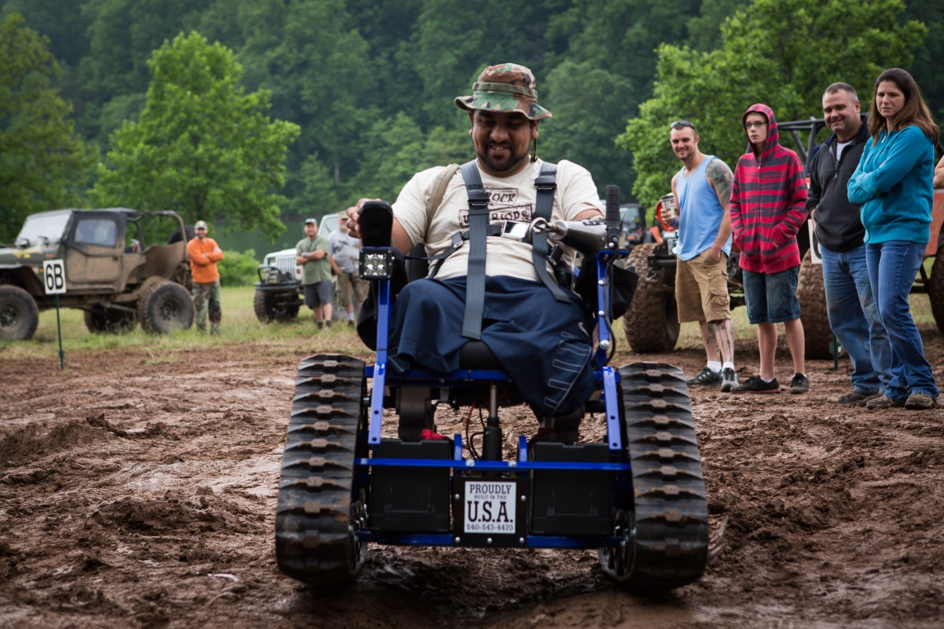

*Update from Nate on the Big Dog’s Spring Fling:*

Every year the 4 Wheel to Heal family looks forward to Big Dogs Spring Fling. This is the time when the leaves are greenest, the water from the mountain is highest, and the weather is usually a perfect 75 degrees. This year was going to have a few more surprises. This was the first event that we were going to have 2 triple amputees present along with a total of 7 Warriors. Additionally this was going to be our first donation of an Action Trackchair.

Friday was a full day of wheeling and fun. That night everyone attended the Mud pit to watch a few vehicles attempt mechanical suicide. Everyone had fun watching the few rigs traverse the impossible and it was announced that Nathan Ramos was going to attempt the mud pit at the next or his rig was going to be painted pink.

Saturday morning was the trackchair presentation and the arrival of Monte Bernardo and Luis Rosa (our chair recipient). Monte already owned a chair and brought it with him. Through significant coordination with the donating company, the distributor and the veteran we were able to present a beautiful sport car blue chair to Luis. These moments were recorded on video and are located on our website. This was a memorable moment for the organization and made Luis and his family very happy.

Rounding out the weekend, Nate took a few of the warriors up to the gun range to have some fun shooting a variety of rifles, shot guns, and pistols.

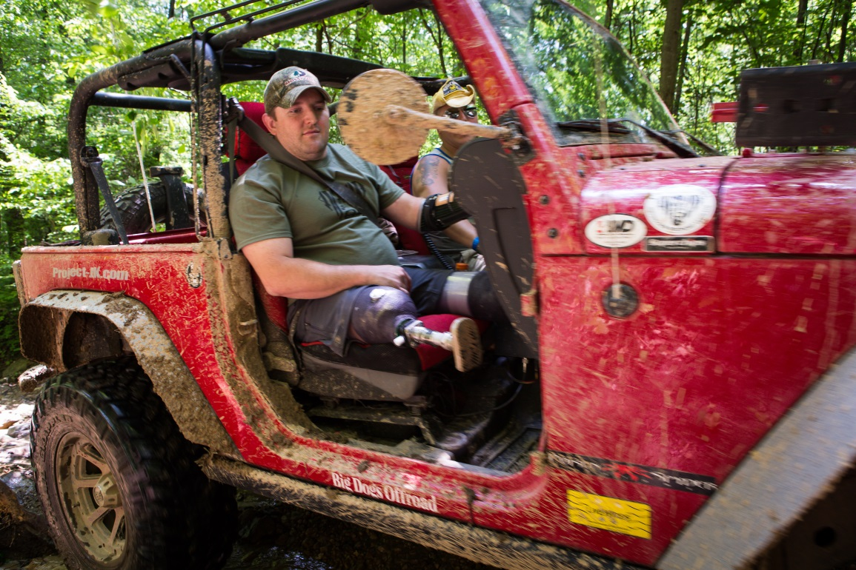

Top: Wounded Warrior Luis Rosa tests out his new Action Trackchair in the mud pit at Big Dogs Spring Fling. The Trackchair was donated by Custom Engineering Services.

Above: Wounded Warrior Monte Bernardo rides shotgun on the trails with 4 Wheel to Heal volunteer Tim Castelow at Big Dog’s Spring Fling.

Photos by Keith Gillan

Main Jambo

Big Dog’s

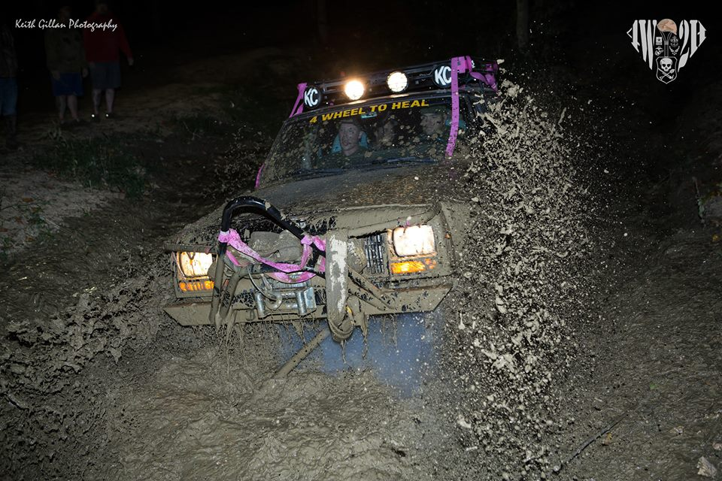

Update from John Purser:

Main Jambo is the largest event of its kind in  
the area, attracting hundreds of wheelers looking to play in mud bogs and extreme rock gardens in an area that is off-limits to 4x4s the rest of the year. Nathan and I met up with a few Warriors Thursday night to set up camp so it was ready for the rest of the Warriors to join us on Friday. We had nine Veterans but really five Warriors. Friday night we had the mud pits and Nathan put on one heck of a show. The crowd tried to pull Nathan out by hand which was really neat to watch. Warriors were plenty muddy and needed to wash off in the showers. Saturday we hit the easy stuff in the morning, driving down Trickle and hitting up Wahoo. After stopping in camp for lunch we hit the harder trails in the afternoon. We closed out with the bonfire that night. Great trip overall.

Nathan Ramos takes warriors John Curtain, John Patterson and Monte Bernardo for a ride in the mud pit in the “Mauler” during Big Dog’s Main Jambo.

Photo by Keith Gillan

PA All Breeds Jeep Show

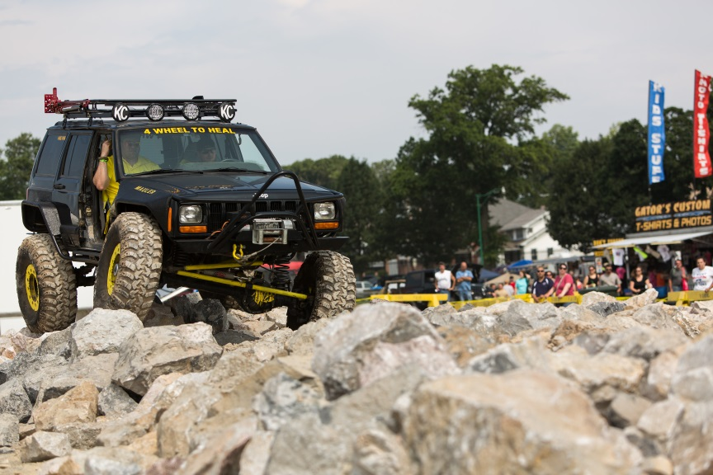

2013 Status Update

**Money Donated:** $73,398.74

**Events:**

Big Dogs Offroad (x5)

PA All Breeds Jeep Show

Motorama

Boulder Bash

TDS Desert Safari

Ventura County Off Road Show

Vet360/ForbiddenJeeps Run

Operation Desert Fun

OMC Offroad Toy and Food Drive

Lucas Oil Offroad Expo

Jeep Creep

Jeep Blessing

**Facebook Numbers:**

Community Page: 7,465 Likes

**Future Plans:**

Bring even more Warriors on Trips

Establish Club Outreach Program

Grow our Volunteer Base

This year’s trip to PA Jeeps All Breed Jeep show was a big stepping stone for 4 Wheel To Heal. We had prime booth space in the center of the arena right across from the obstacle course giving us the opportunity to reach a ton of spectators.

The entire event went well. Warrior John Owen Patterson drove Nate’s Cherokee through the obstacle course.

PA All Breeds has supported 4W2H for the past two years and this year decided to donate $3,500 from this event and make 4 Wheel to Heal a permanent beneficiary moving forward.

The weekend was a reminder of how much support the four wheeling community has for 4 Wheel to Heal.

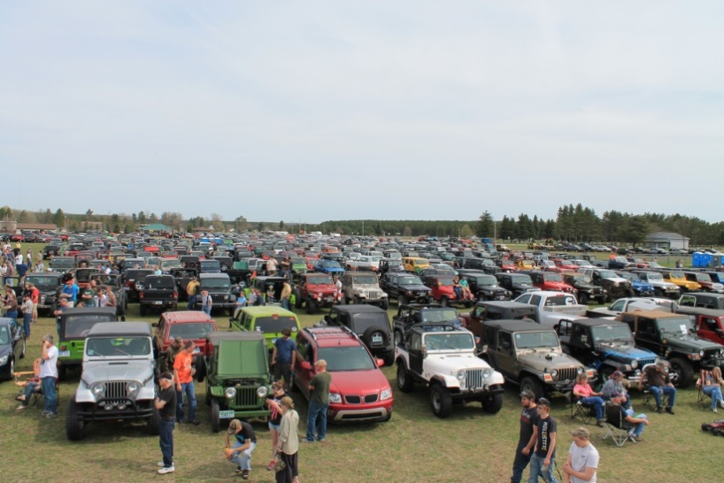

*Update on our Michigan activities from James Mietling:*

Our first year truly operating in Michigan is coming to an end. We attended two events over the last year and have continued to work on finding some disabled veterans to take with us this coming year.

4W2H made its Michigan debut in Mesick at the 12th Annual Jeep Blessing. We had four volunteers and some swag donated from Mumbly’s Off-road. We had a busy booth all day and many people came up and talked to us about their and their children’s time in the service and thanked us for giving back.

In October we attended Jeep Creep. Even though we were more prepared having 4W2H t-shirts and a new supply of vinyl 4W2H stickers from 3 Jeeps Off-road, the weather didn’t want to allow people to enjoy the outdoor vendor areas. Jeep Creep also allowed us to make contacts with JCR Off-road, Unlimited Off-road and Jeep, who all have been talking about helping 4W2H at future events.

2014 has us looking into new events and attending the Jeep Blessing and Jeep Creep again. With our returned presence and more volunteers, we are looking forward to continuing to spread the word about 4 Wheel to Heal throughout the state.

If you’re a wounded veteran in Michigan and would like to go play in the dirt, contact Pam King at Pamela.king@4w2h.org.

**4W2H in Michigan!**

More than 200 rigs met at Ellen’s Corners in Mesick, Michigan, for the 12th Annual Jeep Blessing May 3, 2013. These folks travelled hundreds of miles to have a pastor provide a blessing from God for their off road season.

Photos by James Mietling

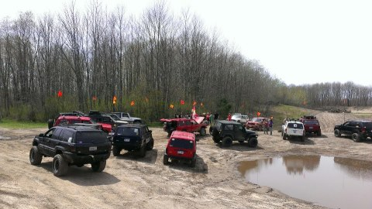

12th Annual Jeep Blessing hosted by the Cadillac Jeepers,

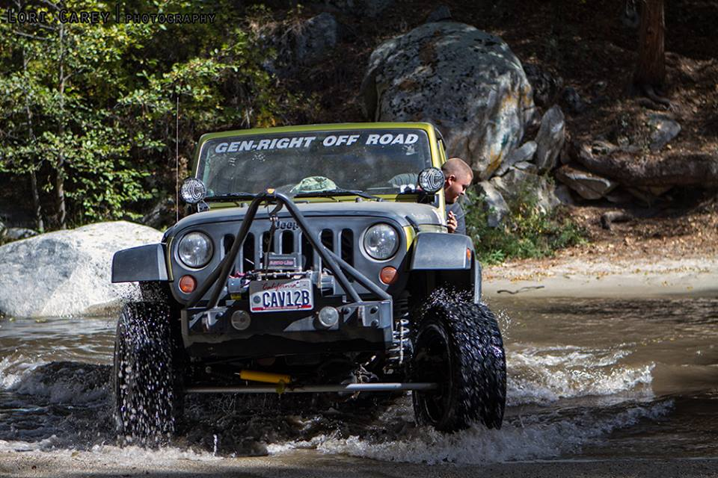

**OMC Offroad Third Annual Holiday Food and Toy Drive**

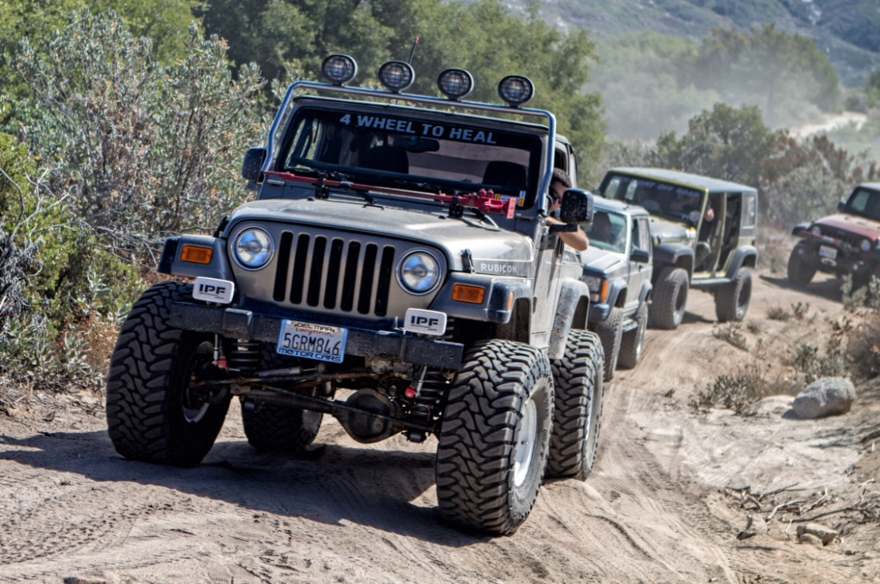

Above: 4W2H Co-Founder and Treasurer Mark Schultz led the 12-rig trail run at the OMC Offroad 3rd Annual Holiday Food and Toy Drive in Banning, California on October.

Right: Wounded veteran Steven Shaw navigates through a small wash in the San Jacinto Mountains.

OMC Offroad owner Aaron Eaton was introduced to 4W2H in May 2013 at another event and was intrigued with the mission and excited to show his support for wounded veterans by inviting 4W2H to lead the run. The annual event benefits the elderly and the homeless in the community by donating proceeds to Carol’s Kitchen and Blessed Kateri Tekakwitha, two local charitable organizations.

Photos by Lori Carey

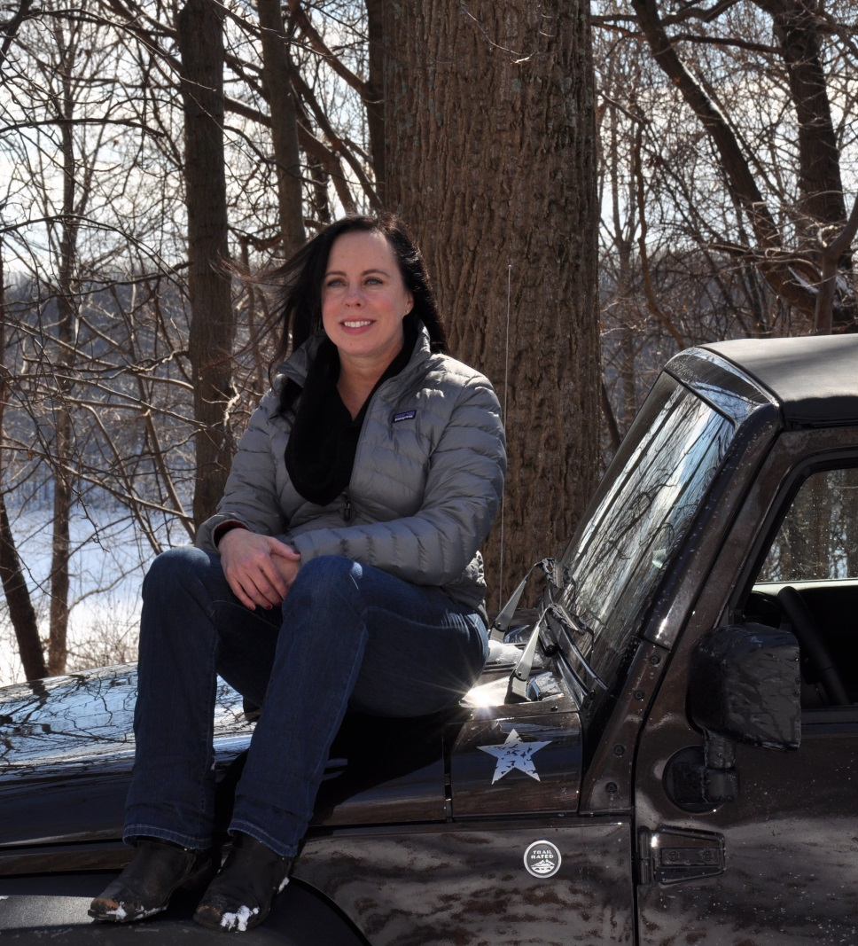

**Welcome Pam!**

Pam King is 4 Wheel to Heal’s Warrior Liaison. We’d like to say thank you for her support and welcome to our organization!

Four Wheel to Heal, Inc.

**Four Wheel to Heal, Inc.**

**was founded by**

Nathan Ramos

John Purser

Mark Schultz

John Griffin

**Editor**

Lori Carey

Lori@loricarey.com

Mark Schultz

Mark.schultz@4w2h.org

**Photography**

Lori Carey

Keith Gillan

James Mietling

**Regular Contributors**

Lori Carey

Mark Schultz

Nathan Ramos

John Purser

Keith Gillan

**Editorial Information**

4 Wheel to Heal welcomes freelance contributors and letters with a focus on enthusiasts, off road vehicles, upgrades and experience as well as service related stories from military and non-military personnel. Text is accepted by email in Word format. Please note, 4 Wheel to Heal is not obligated to publish the information, may edit text and will not be liable for any errors or omissions in the publishing of the material.

Photographic material should be of good to high quality and clearly named. Images will be accepted by email, USB drive or print copies.

4 Wheel to Heal will return original photographic material, but accepts no responsibility for their loss or damage.

**Disclaimer**

The information contained in this newsletter, whether in editorial matter, feature articles or advertisements, is not published on the basis that the publisher accepts or assumes liability or responsibility to any reader of this newsletter for any loss or damage resulting from the correctness or application of such information.

Photography

Nathan Ramos

John Purser

Keith Gillan

Regular Contributors

Mark Schultz

Nathan Ramos

John Purser

John Griffin

Editorial Information

4 Wheel to Heal welcomes freelance contributors and letters with a focus on enthusiasts, off road vehicles, upgrades and experience as well as service related stories from military and non-military personnel. Text is accepted by email in Word format. Please note, 4 Wheel to Heal is not obligated to publish the information, may edit text and will not be liable for any errors or omissions in the publishing of the material.

Photographic material should be of good to high quality and clearly named. Images will be accepted by email, USB drive or print copies.

4 Wheel to Heal will return original photographic material, but accepts no responsibility for their loss or damage.

Disclaimer

The information contained in this newsletter, whether in editorial matter, feature articles or advertisements, is not published on the basis that the publisher accepts or assumes liability or responsibility to any reader of this newsletter for any loss or damage resulting from the correctness or application of such information.

Pamela (Pam) King is a dedicated volunteer serving members of the military and their families.  She has supported many organizations and roles, mainly at Walter Reed National Naval Medical Center and the Wounded Transition Battalion at Ft. Belvoir, including the USO, CAUSE-CDEL, and the American Red Cross for the past several years.  Pam is the proud granddaughter of a WWII Purple Heart Marine and the daughter of an Airman; she is grateful for them giving her a strong foundation in supporting our veterans and their families.  Pam is a   
Corporate Paralegal for a software firm and recently completed her Master’s degree at Georgetown University. While at Georgetown University, Pam wrote her thesis on the Effects of Agent Orange on U.S. Servicemen during the Vietnam War. She loves the outdoors, camping, off roading, her JK, and her rescue dog Frankie.   
 Pam, as the Warrior Liaison, is the contact person for 4 Wheel to Heal at the hospitals as well as to warriors located elsewhere working to get them out for a weekend of off roading and camping.

4 Wheel to Heal is a non-profit organization that needs your support!

We are committed to using 100% of your donations to taking wounded veterans on the trails. Your commitment helps pay for food, camping supplies and registration fees for these warriors.

**Visit www.4w2h.org/donations and give today!**

4 Wheel to Heal is also an all-volunteer run organization. And we need volunteers to help our organization grow. If you have a skill set you think would help our organization, please let us know! We are looking for, but are not limited to: accounting services, non-profit legal experience, event coordination, social media, website updates, and much, much more!

**If you’re interested, email us at info@4w2h.org.**

**We need Your Help!**